**Project:**

**A Simple Text Editor Application**

Make a program (application) that allows you to create new text files and open existing text files. The file contents are displayed in a text area. You can also change the font and style of the text that is displayed in the text area.

The application’s window is shown in the following. Line wrapping is turned on, using word wrap style, and the text area is in a scroll pane.

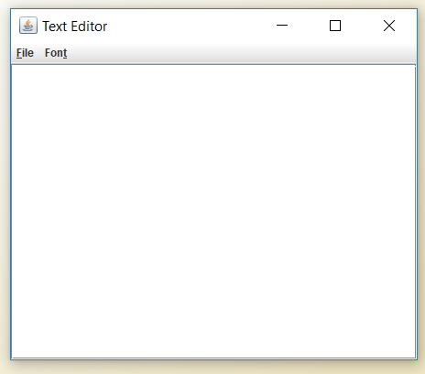

The application uses a menu system to perform these operations, which is shown in the following:

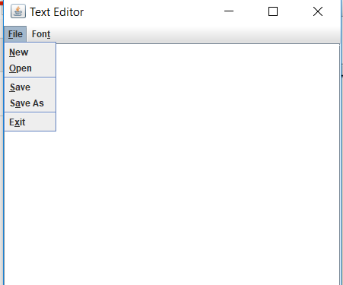

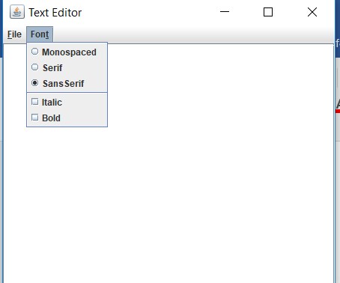

Each menu item generates an action event that is handled by an action listener. The following

section presents a summary of the actions performed by each menu item.

**File Menu**

New This menu item clears any text that is stored in the text area. In addition, the class’s filename field is set to null. The filename field contains the path and name of the file that is currently displayed in the text area.

Open This menu item displays a file chooser that allows the user to select a file to open. If the user selects a file, it is opened and its contents are read into the text area. The path and name of the file are stored in the filename field.

Save This menu item saves the contents of the text area. The contents are saved to the file with the name and path stored in the filename field. If the filename field is set to null, which would indicate that the file has not been saved yet, then this menu item performs the same action as the Save As menu item. Save As This menu item displays a file chooser that allows the user to select a location

and file name. The contents of the text area are written to the selected file, and the path and file name are stored in the filename field. (Be careful when using this menu item. As it is currently written, this application does not warn you when you are about to overwrite an existing file!) Exit This menu item ends the application.

**Font Menu**

Monospaced This radio button menu item changes the text area’s font to Monospaced.

Serif This radio button menu item changes the text area’s font to Serif.

SansSerif This radio button menu item changes the text area’s font to SansSerif.

Italic This check box menu item changes the text area’s style to italic.

Bold This check box menu item changes the text area’s style to bold.